# Lab 3. Flow Notifications and Conditions

**Author:** Serge Luca aka “Doctor Flow”

**Learning objectives:** Notifications and conditions

**Duration:** 20 minutes

**Scenario:** You have set an Out of Office notification in your e-mail box. In the Out of Office message, you will mention that if the message is urgent, people can send an e-mail containing just one exclamation point ‘!’. You also want to get a mobile notification when such message shows-up.

**If you want to take a look at the solution:** navigate to the [**Important e-mails notification template.**](https://preview.flow.microsoft.com/en-us/galleries/public/templates/cf2d73c1a0484beba85e78fad4420969/send-me-a-push-notification-for-important-emails/)

**If you want to start the lab from scratch:**

## Task 3.1: Create and test a notification flow

1. If you haven’t already done so install the **Microsoft Power Automate** application on your phone and enable notifications.
2. Create a new Flow from the template [**Receive push notifications for new Office 365 Outlook emails**](https://us.flow.microsoft.com/en-us/galleries/public/templates/1900363039a911e7870df906aa521b7a/receive-push-notifications-for-new-office-365-outlook-emails/)**.**
   1. **New > Create from template**
   2. Search for **push notification outlook** and click the required template.

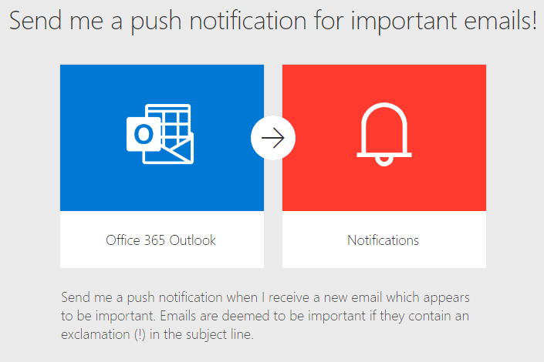

* 1. Click **Continue**.

**Note:** If you have not created connections for Notifications, you will need to do so in order to provision the template.

* 1. Save the flow as **Important e-mails notifications**.

1. Add a condition to check if the mail subject contains **!**
   1. Between the **trigger** and the **Send** action, add a **Condition control**.
   2. In the left **Choose a value** text box, use the **Dynamic content** tab to select **Subject** from the trigger.
   3. In the middle text box, select the **contains** operation.
   4. In the right **Choose a value** text box, type **!**

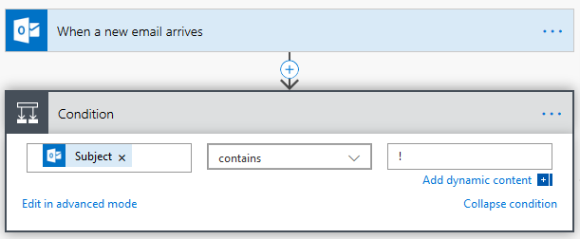

* 1. Update the **If yes** condition by moving the notification action into it:

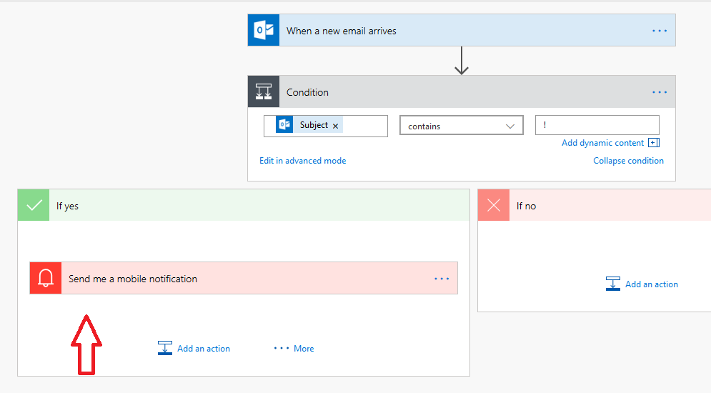

1. Test the Flow by sending an e-mail to yourself with the subject **You won the lottery!**

You should get a phone notification which looks like this (in Android)

**Note:** When using your Flow mobile application, you may be prompted to enable notifications.

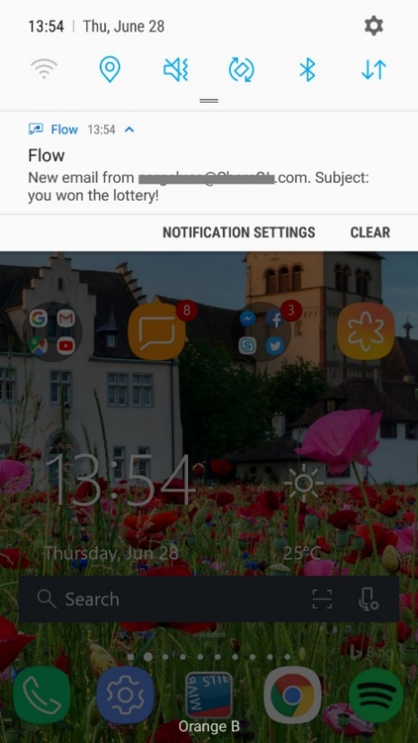

## Task 3.2: Filter the trigger

1. The condition can be avoided by filtering directly the e-mails in the trigger. Click the trigger and **add !** in the **Subject Filter**

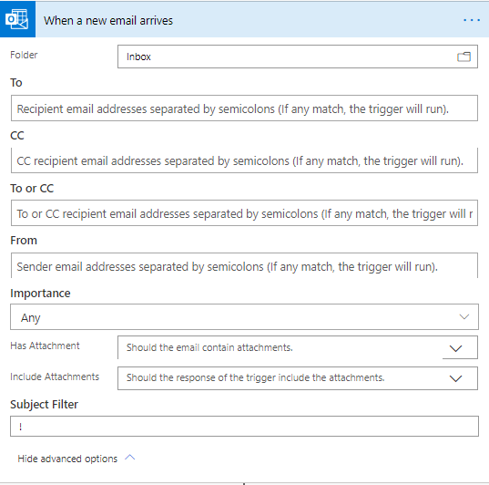

1. You can remove the Condition and test again.
2. You should now that more complex expression can be defined in the trigger. In the trigger click the Settings option:

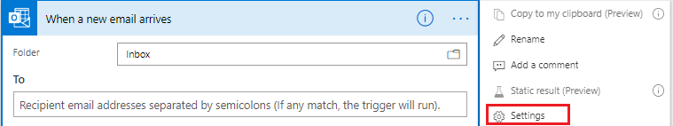

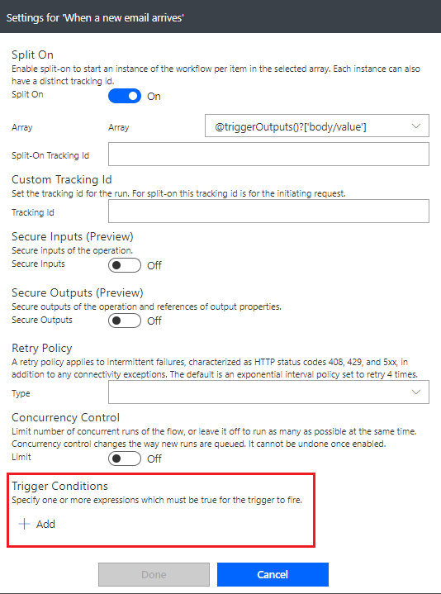

1. Click Add
2. Paste the following expression in the trigger condition textbox

*@contains(triggerOutputs()?['body/subject'],'!')*

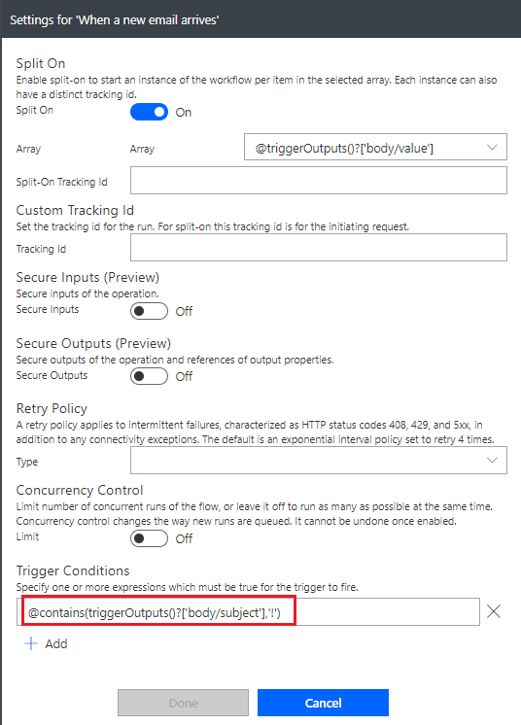

(You will become more familiar with expressions in the next labs).

1. **Remove the Subject Filter** you defined before
2. **Save your flow** and test it again

## We need your feedback

Do you want to report an issue or to suggest something? We need your feedback: <https://github.com/Power-Automate-in-a-day/Training-by-the-community/issues>